Date- 01.08.2025

1)

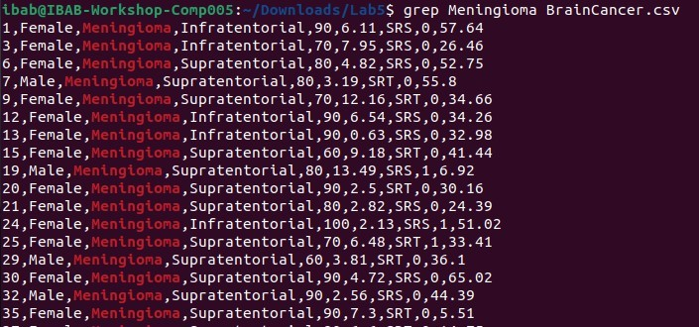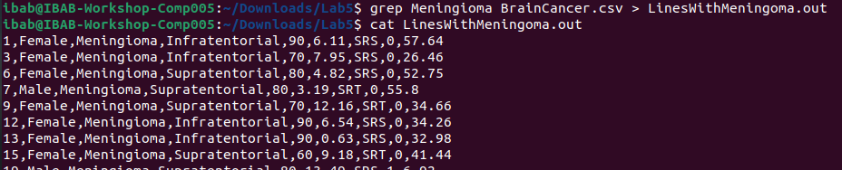

2)



3)



4) 4 people have the lowest ki value which is equal to 60

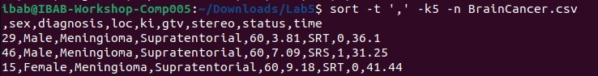

5)

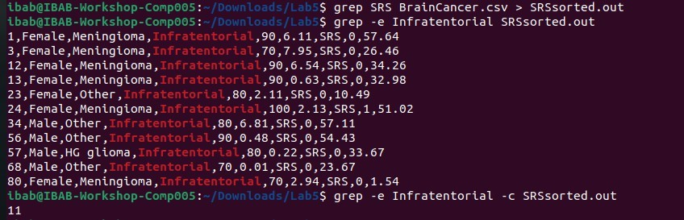

6)

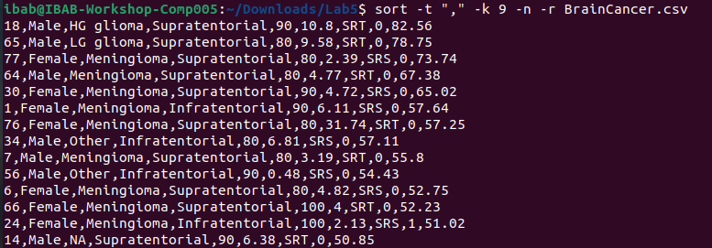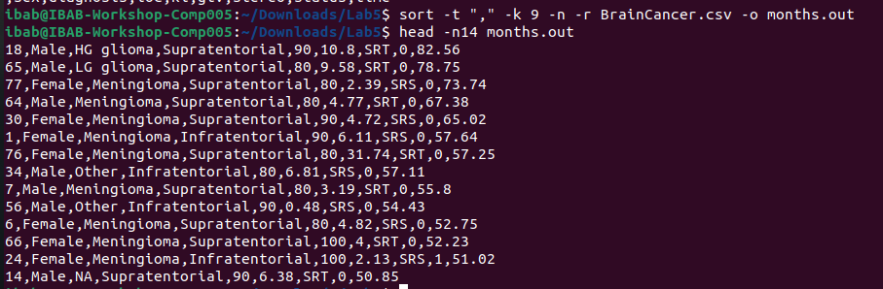

7) only 1 person has HG glioma who has survival times more than 50 months.

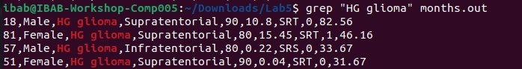

8)

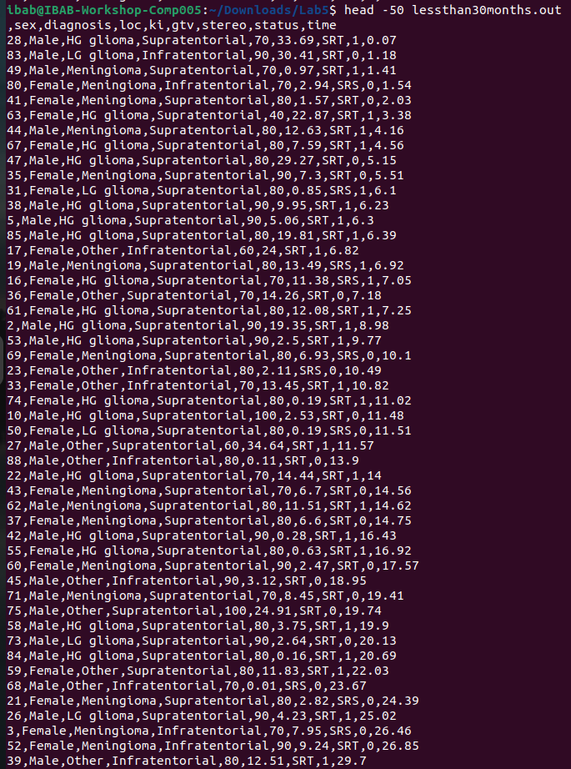

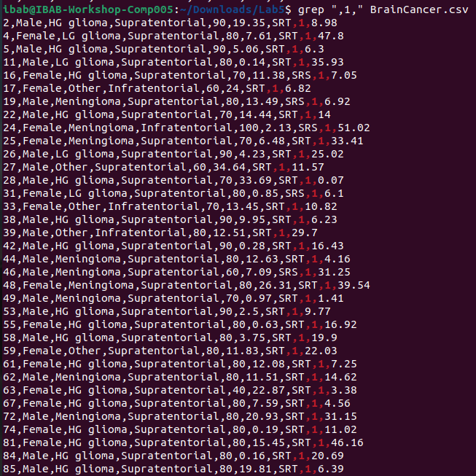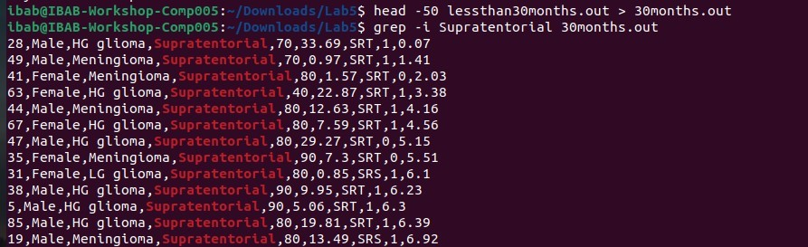

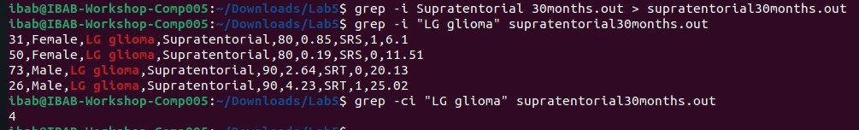

9)grep is case sensitive, -i can be used to ignore case sensitivity

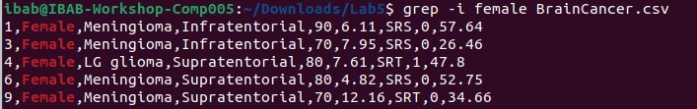

10)



We can use -v to list non matching lines, However the header is included while counting and hence the count comes out as 35+header = 36.

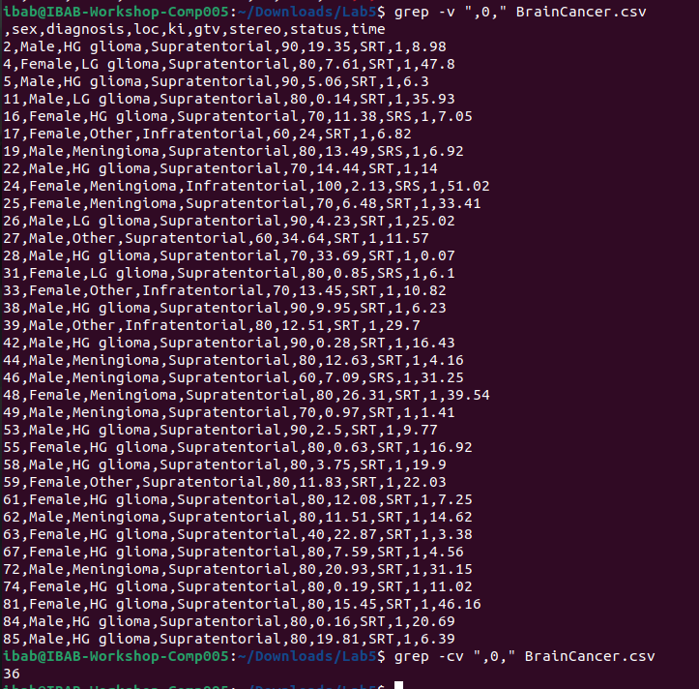

11)

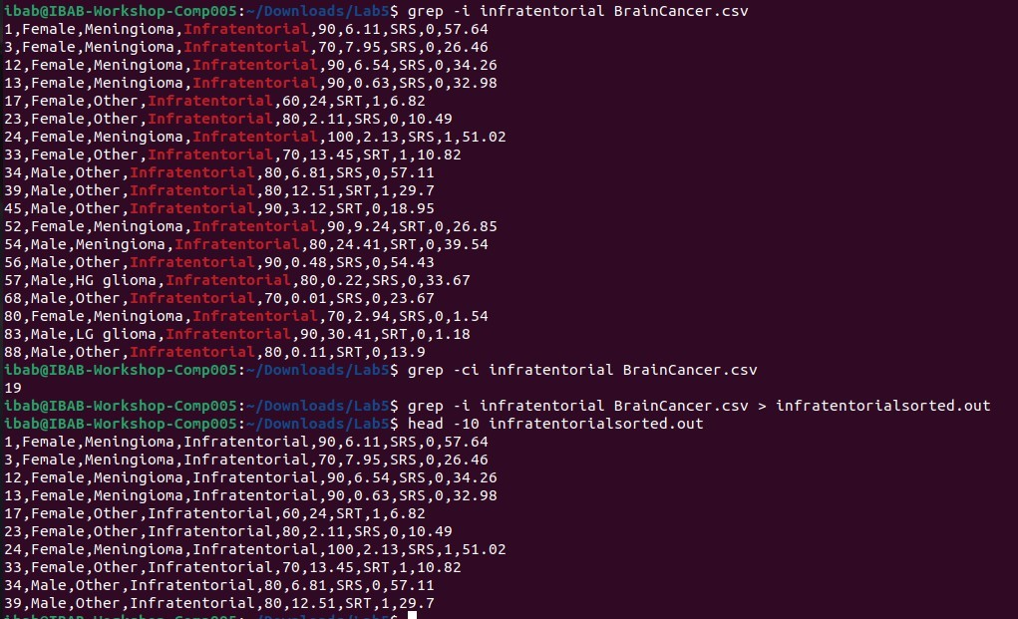

12)

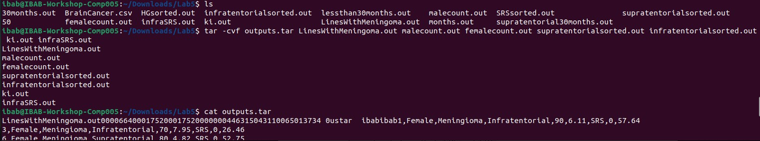

13)

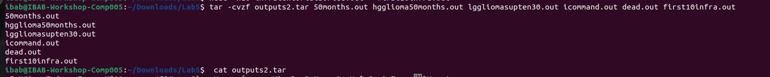

14)

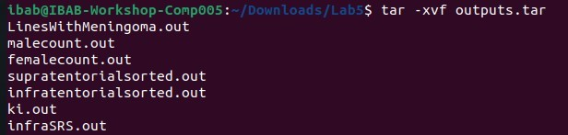

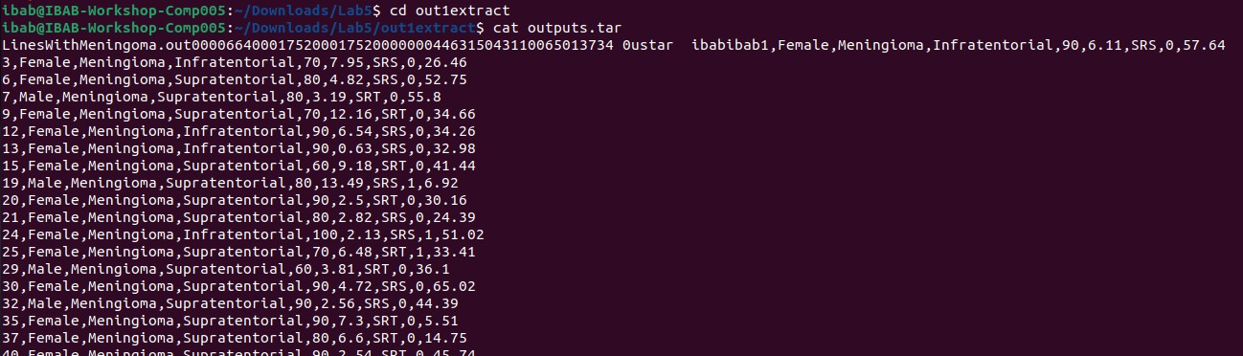

15)

